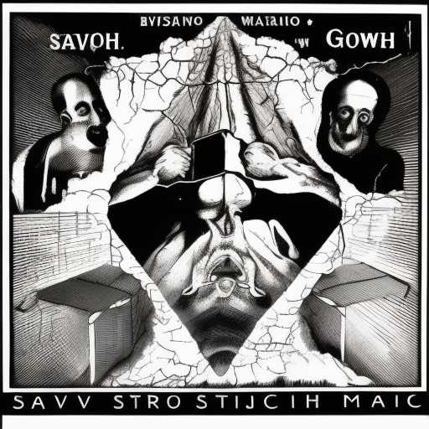
ADVERSARIES OF SOULS

The powers of the air are preparing for the biggest war
With satellites, bombers, viruses & snake oil
They enrich themselves on the su ering of the ignorant
They purport to be saviors
Draped in the ags of yesteryear's myths
They beckon us to destruction
Problem, reaction, solution

Our saviors will not be merchant priests
Our saviors will not be those brandishing swords

But most especially
Our saviors will not be a breakaway class of sociopaths
Who fancy externalized hierarchies of MK technicians
Who extort the wealth of nations
Who store the digital history of man in bunkers below the earth
Who monopolize the eye of providence
Who bear down like gravity upon hapless test subjects

